我真想当一只小狗
http://zuowen.mofangge.com/html/zwDetail/20150815/xcv1318153.ht

每当有人问我想当什么，我就说想成为一只小狗，别人都说我有点神经不正常。但你要是知道了这其中的原因，也一定会支持我的。
现在的宠物狗啊，生活过得比人还要好。就说我家的那只叫“宝贝”的狗吧，爸爸居然还管它叫“儿子”！它每天可以说是吃香的喝辣的，今天吃鱼丸,明天吃牛肉，后天吃骨头，算起来每个月光给它买吃的，就要花去几百元钱啊！而我每个月的零花钱才25元，和它相比，简直是贫富两重天啊！
我家的那只宝贝狗，每天穿的衣服都不一样。今天穿粉色的小裙子，明天穿白色的小马甲，后天可能穿黄色的小背心，有时我都看不过眼了，它也太牛气了，我都没有这样的待遇啊！所以我就经常要妈妈也给我买一些裙子衣服之类的，可妈妈说我穿那么漂亮的衣服不像个学生样，你说这都是哪跟哪儿呀！我一听气就不打一处来，我还不如一只小狗穿得好呢！唉！
我家的宝贝呀，每天都和妈妈一起去散步。有时天气冷，妈妈怕它冻着了，还带一件衣服备用，比照顾我还细心，真让人嫉妒啊！我就向妈妈抱怨，散步也不带我。可妈妈说要我在家多做些习题更进步一些，不该去攀比小狗。看着小狗它昂头挺胸向前走的样子，好像在气我啊！
你们说说，我想成为一只宠物狗的想法难道真的很过分吗？

Pre-class Activity 1:
Graphic Organizer: 《我真的想当一只小狗》
Let’s see if you have learned on finding key information from a text. Please read the article again. This time, please fill in the graphic organizer with key information.
主题：main point
关于: about
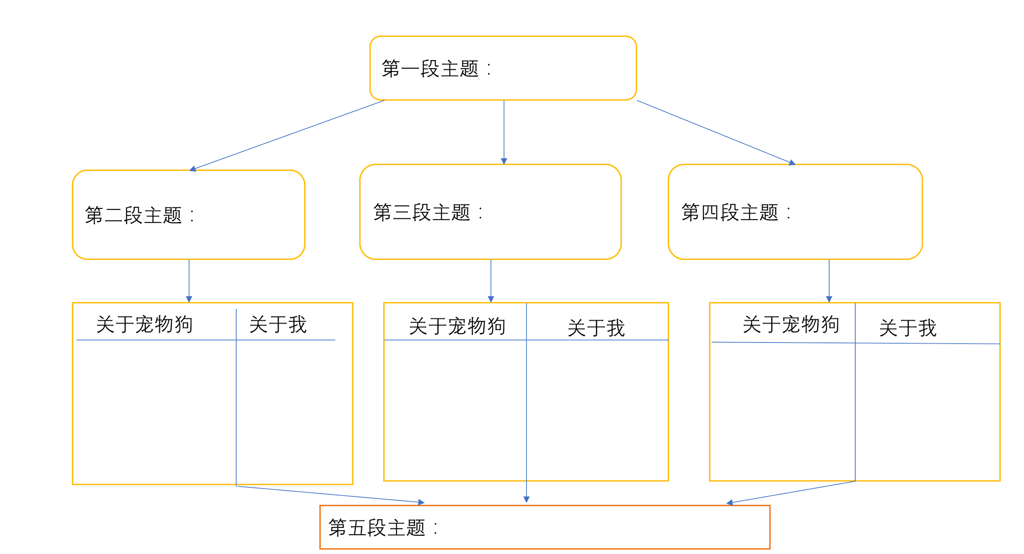

Answer Key
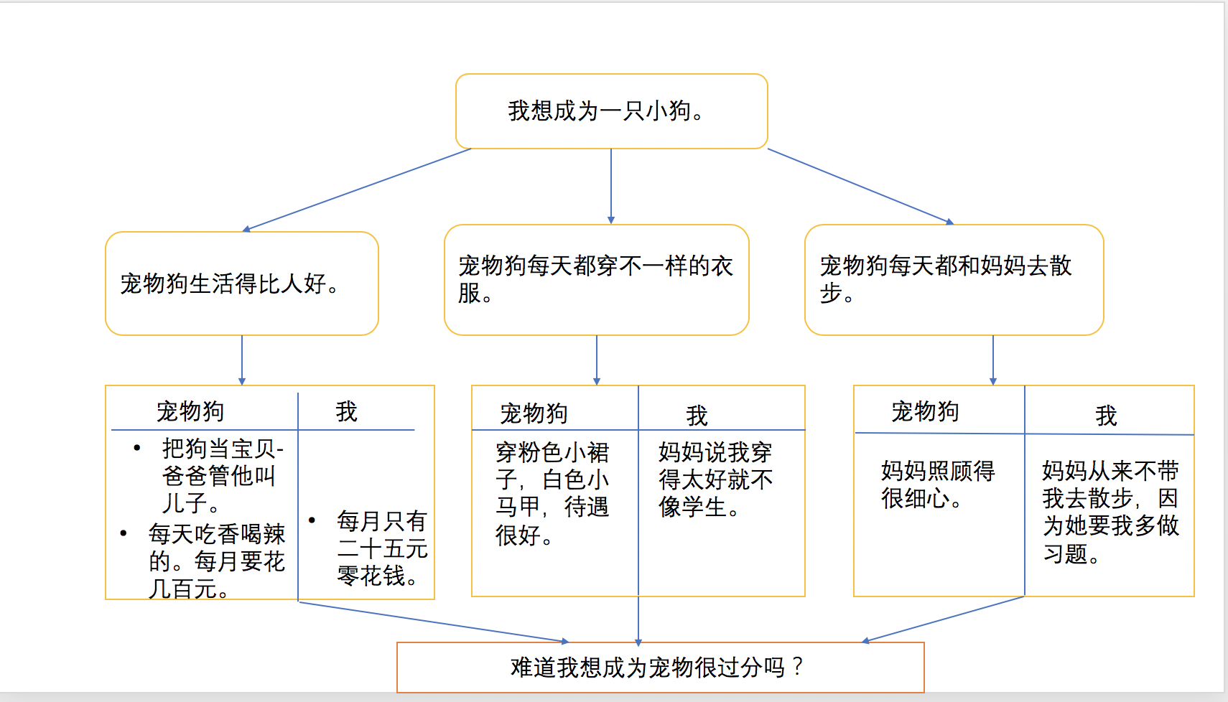

Pre-class Activity 2:
Comprehension Questions:

1. What might be the author’s point of view on pet ownership?
- In support of pet ownership.
- Against pet ownership.
- Does not exhibit an opinion on pet ownership.
- Cannot tell from text.

2. How do you think the author feels towards the pet?
- The author loves this dog.
- The author hates this dog.
- The author is jealou of this dog.
- The author does not talk about any feelings towards this dog.

3. Based on this passage, what do you think is the main message from the author?
- Children should be cherished and spoiled, too!
- Pet ownership takes up a lot of one’s finances and time.
- Some parents are too strict.
- Some pets are evil.

4. If you were to give a new title to this article, which of the following will be the best fit?
- 我们家的宝贝狗
- 我也要被宠
- 爸妈的最爱
- 我也要跟狗狗玩

5. What is the key sentence of the passage?
- 我想成为一只小狗
- 宠物狗生活过得比人还要好
- 我不该去攀比小狗
- 小狗好像在气我
In-class Activity 2: Read the article again. Highlight some key phrases which the author would say to the parents.

每当有人问我想当什么，我就说想成为一只小狗，别人都说我有点神经不正常。但你要是知道了这其中的原因，也一定会支持我的。
现在的宠物狗啊，生活过得比人还要好。就说我家的那只叫“宝贝”的狗吧，爸爸居然还管它叫“儿子”！它每天可以说是吃香的喝辣的，今天吃鱼丸,明天吃牛肉，后天吃骨头，算起来每个月光给它买吃的，就要花去几百元钱啊！而我每个月的零花钱才25元，和它相比，简直是贫富两重天啊！
我家的那只宝贝狗，每天穿的衣服都不一样。今天穿粉色的小裙子，明天穿白色的小马甲，后天可能穿黄色的小背心，有时我都看不过眼了，它也太牛气了，我都没有这样的待遇啊！所以我就经常要妈妈也给我买一些裙子衣服之类的，可妈妈说我穿那么漂亮的衣服不像个学生样，你说这都是哪跟哪儿呀！我一听气就不打一处来，我还不如一只小狗穿得好呢！唉！
我家的宝贝呀，每天都和妈妈一起去散步。有时天气冷，妈妈怕它冻着了，还带一件衣服备用，比照顾我还细心，真让人嫉妒啊！我就向妈妈抱怨，散步也不带我。可妈妈说要我在家多做些习题更进步一些，不该去攀比小狗。看着小狗它昂头挺胸向前走的样子，好像在气我啊！
你们说说，我想成为一只宠物狗的想法难道真的很过分吗？
Activity 3: Now, using those key phrases, compose a letter to the parents
expressing the author’s point of view.

Summative: (Alternative perspectives)
What might this story look like from the pet dog’s perspective? Might there
be a special reason why the dog was introduced to the family? Take on the
perspective of the pet dog. Write a journal entry on the dog’s daily life being
in this household. Identify the purpose of being adopted into the family.
Write about what the dog does throughout the day.

